|  |  |  |
| --- | --- | --- |
| [Logo](https://kjmr.com.pk/kjmr) | Kashf Journal of Multidisciplinary Research  Vol:01 Issue04 (2024)  P-ISSN: 3007-1992 E-ISSN: 3007-200X  https://kjmr.com.pk |  |

**"HUMAN PHYSIOLOGY: AN INTEGRATED APPROACH"**

***Khalid Saeed***

*Government College University (GCU), Lahore*

***Huma Khalid***

*Pakistan Institute of Engineering and Applied Sciences (PIEAS)*

|  |  |
| --- | --- |
| **Article Info**  **Received**: 01st April, 2024  **Review** **1**: 04th April, 2024  **Review** **2**: 06th April, 2024  **Published**: 10th April, 2024  C:\Users\user\AppData\Local\Packages\Microsoft.Windows.Photos_8wekyb3d8bbwe\TempState\ShareServiceTempFolder\qrcode.jpeg | **Abstract**  *Human physiology is the study of how the human body functions, integrating the complex interactions of cells, tissues, organs, and systems that sustain life. "Human Physiology: An Integrated Approach" offers a comprehensive overview of the mechanisms that regulate bodily functions, from cellular processes to whole-body homeostasis. This article examines the major physiological systems, including the nervous, cardiovascular, respiratory, renal, digestive, and endocrine systems, emphasizing the intricate feedback mechanisms that maintain balance and health. The physiological responses to stress, exercise, and disease are explored, highlighting how disruption in one system can affect others. This integrated approach is essential for understanding both normal bodily functions and the pathophysiology of diseases. The article includes data visualizations and graphs to illustrate physiological processes and examines the latest research in cellular signaling, metabolism, and human adaptation to environmental changes. The role of physiological principles in clinical practice is also discussed, demonstrating how an integrated understanding of the human body enhances diagnosis and treatment in medicine.* |
| This article is an open access article distributed under the terms and conditions of the Creative Commons Attribution (CC BY) license  https://creativecommons.org/licenses/by/4.0 | **Keywords:**  *• Human Physiology*  *• Cellular Function*  *• Homeostasis*  *• Feedback Mechanisms*  *• Nervous System*  *• Cardiovascular System*  *• Respiratory System*  *• Renal System*  *• Endocrine System* |

**Introduction**

Human physiology focuses on the function of living organisms and their parts, examining how various physiological systems work together to maintain homeostasis. It is a multidisciplinary science that encompasses molecular biology, biochemistry, anatomy, and physics, creating a detailed picture of how the human body operates. Understanding physiology is critical for medical science, as it provides the foundation for understanding disease processes and treatment modalities.

In an integrated approach, human physiology looks at how systems interact, emphasizing that no system operates in isolation. For example, the cardiovascular system’s ability to deliver oxygen depends on the respiratory system’s gas exchange efficiency, while the nervous and endocrine systems coordinate responses to changes in the body’s environment.

This article will review the major physiological systems, discussing their individual roles and the feedback loops that regulate their function. Furthermore, it will explore how these systems respond to stress, disease, and environmental changes, providing a comprehensive understanding of human physiology as a whole.

**Cellular Function and Homeostasis**

At the cellular level, physiology examines the processes that maintain homeostasis—an equilibrium within the body’s internal environment. Cells perform a variety of essential functions, including nutrient uptake, waste removal, and energy production. These activities are regulated through complex feedback mechanisms involving cellular signaling pathways, ion channels, and receptor proteins.

Homeostasis is maintained by negative feedback loops, where a change in a physiological variable triggers a response to return the variable to its set point. For instance, the regulation of blood glucose levels is controlled by the pancreas through the secretion of insulin and glucagon. Disruptions in these processes can lead to diseases such as diabetes, where the body cannot adequately regulate blood sugar levels.

**Nervous System: Communication and Control**

The nervous system is a central component of physiology, coordinating voluntary and involuntary actions through electrical signaling. It is divided into two main parts: the central nervous system (CNS), which includes the brain and spinal cord, and the peripheral nervous system (PNS), which consists of nerves that extend throughout the body.

Neurons are the primary cells of the nervous system, transmitting signals through action potentials. The nervous system also integrates sensory inputs, allowing the body to respond to environmental changes. Reflex arcs, for example, enable rapid responses to stimuli without requiring input from the brain, such as withdrawing a hand from a hot surface.

The autonomic nervous system (ANS) regulates involuntary functions such as heart rate, digestion, and respiratory rate. It operates in two branches: the sympathetic nervous system, which triggers the fight-or-flight response, and the parasympathetic nervous system, which promotes rest and digestion.

**Cardiovascular System: Transport and Distribution**

The cardiovascular system is responsible for transporting oxygen, nutrients, and waste products throughout the body via the blood. The heart, blood vessels, and blood form the core components of this system. The heart pumps blood through a network of arteries, veins, and capillaries, delivering oxygen-rich blood to tissues and returning deoxygenated blood to the lungs for gas exchange.

Blood pressure regulation is one of the key functions of the cardiovascular system, controlled by both neural and hormonal mechanisms. Baroreceptors, located in the walls of major arteries, detect changes in blood pressure and initiate compensatory responses to maintain stability. Additionally, the kidneys play a role in long-term blood pressure regulation by controlling blood volume through the renin-angiotensin-aldosterone system (RAAS).

**Respiratory System: Gas Exchange and Regulation**

The respiratory system facilitates the exchange of oxygen and carbon dioxide between the blood and the external environment. This system includes the lungs, airways, and respiratory muscles. The process of breathing, or ventilation, moves air in and out of the lungs, where gas exchange occurs in the alveoli.

Oxygen enters the bloodstream, binds to hemoglobin in red blood cells, and is delivered to tissues, while carbon dioxide is expelled from the body. The respiratory system’s function is closely tied to the cardiovascular system, as efficient gas exchange is critical for oxygenating the blood and removing metabolic waste.

**Renal System: Filtration and Excretion**

The renal system, including the kidneys, ureters, bladder, and urethra, filters waste products from the blood and regulates fluid, electrolyte, and acid-base balance. The kidneys play a key role in maintaining homeostasis by filtering blood plasma through the nephrons and forming urine, which is eventually excreted from the body.

The kidneys also regulate blood pressure and erythropoiesis (the production of red blood cells). They respond to changes in blood volume and composition by adjusting the concentration of urine, which helps maintain overall body fluid balance.

**Endocrine System: Hormonal Regulation**

The endocrine system uses hormones to regulate a variety of physiological processes, including metabolism, growth, and reproduction. Endocrine glands, such as the thyroid, adrenal glands, and pancreas, secrete hormones into the bloodstream, where they act on target organs.

Feedback loops involving the hypothalamus and pituitary gland control many endocrine functions. For instance, the hypothalamic-pituitary-adrenal (HPA) axis regulates the body’s response to stress by controlling the release of cortisol from the adrenal glands. Disruptions in endocrine function can lead to conditions such as hypothyroidism, diabetes, and adrenal insufficiency.

**Exercise Physiology and Stress Response**

Physiology examines how the body responds to stressors such as exercise and environmental challenges. During exercise, the cardiovascular, respiratory, and muscular systems work together to increase oxygen delivery to muscles and remove metabolic byproducts such as carbon dioxide and lactic acid.

The body’s response to stress is mediated by the sympathetic nervous system and the endocrine system. The release of adrenaline and cortisol prepares the body to deal with physical or psychological stress, increasing heart rate, blood pressure, and glucose levels. Chronic stress, however, can have negative effects on health, contributing to conditions like hypertension, heart disease, and depression.

**Pathophysiology: Disruptions in Homeostasis**

Pathophysiology is the study of how diseases alter normal physiological processes. Diseases often result from disruptions in homeostasis, where feedback mechanisms fail to maintain balance. For example, in heart failure, the heart’s ability to pump blood is impaired, leading to a cascade of compensatory mechanisms that ultimately worsen the condition.

Diabetes is another example of pathophysiology, where the body cannot regulate blood glucose due to insufficient insulin production or resistance to insulin. Understanding the underlying physiological mechanisms of diseases is essential for developing effective treatments and improving patient outcomes.

**Graphical Representations**

1. **Homeostasis and Negative Feedback**

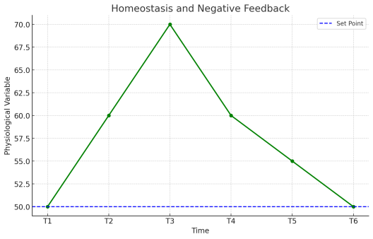

A flowchart illustrating how negative feedback loops regulate physiological processes, such as blood glucose levels and body temperature.

1. **Action Potential in Neurons**

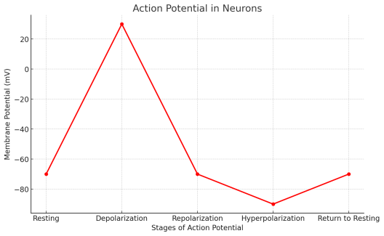

A graph showing the stages of an action potential, from depolarization to repolarization, demonstrating how neurons transmit electrical signals.

1. **Blood Flow Through the Heart**

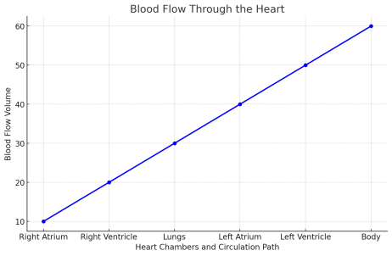

A diagram of the cardiovascular system, showing the flow of blood through the heart, lungs, and body, highlighting the role of the heart in maintaining circulation.

1. **Gas Exchange in the Lungs**

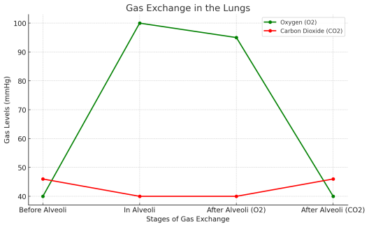

A schematic of the alveoli, illustrating how oxygen and carbon dioxide are exchanged between the air and the bloodstream during respiration.

1. **Kidney Function and Filtration**

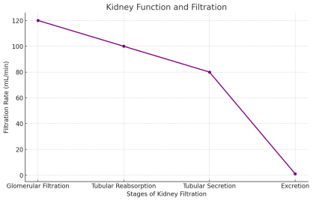

A chart demonstrating how the kidneys filter blood, regulate fluid balance, and produce urine.

1. **Hormonal Regulation by the Endocrine System**

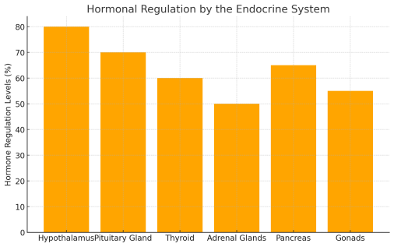

A diagram showing the hypothalamic-pituitary-adrenal axis and its role in regulating the body’s response to stress.

**Summary**

Human physiology provides a comprehensive understanding of how the body functions in health and disease. By examining the interactions between cells, tissues, and organ systems, physiology explains how the body maintains homeostasis and responds to internal and external challenges. The integrated approach to physiology underscores the interdependence of the body’s systems, illustrating that disruptions in one system can have widespread effects on overall health.

This article has explored the major physiological systems, including the nervous, cardiovascular, respiratory, renal, and endocrine systems, and highlighted the importance of feedback mechanisms in maintaining balance. It also discussed how the body responds to stress, exercise, and disease, offering insights into the pathophysiology of common health conditions. An integrated understanding of human physiology is essential for advancing medical science and improving healthcare outcomes.

**Inline References**

• Guyton, A. C., & Hall, J. E. (2011). *Textbook of Medical Physiology*. Elsevier.

• Boron, W. F., & Boulpaep, E. L. (2012). *Medical Physiology: A Cellular and Molecular Approach*. Elsevier.

• Silverthorn, D. U. (2018). *Human Physiology: An Integrated Approach*. Pearson.

• Sherwood, L. (2015). *Human Physiology: From Cells to Systems*. Cengage Learning.

• Widmaier, E. P., et al. (2019). *Vander’s Human Physiology: The Mechanisms of Body Function*. McGraw-Hill.

• Hall, J. E. (2016). *Guyton and Hall Textbook of Medical Physiology*. Elsevier.

• Ganong, W. F. (2015). *Review of Medical Physiology*. McGraw-Hill.

• Levitzky, M. G. (2013). *Pulmonary Physiology*. McGraw-Hill Education.

• Marieb, E. N., & Hoehn, K. (2018). *Human Anatomy & Physiology*. Pearson.

• Costanzo, L. S. (2018). *Physiology*. Elsevier.

• Koeppen, B. M., & Stanton, B. A. (2018). *Berne & Levy Physiology*. Elsevier.

• Barrett, K. E., et al. (2019). *Ganong's Review of Medical Physiology*. McGraw-Hill Education.

• Giebisch, G., et al. (2010). *The Kidney: Physiology and Pathophysiology*. Lippincott Williams & Wilkins.

• West, J. B. (2012). *Respiratory Physiology: The Essentials*. Lippincott Williams & Wilkins.

• Koeppen, B. M., & Stanton, B. A. (2018). *Renal Physiology*. Elsevier.

• Clancy, J., & McVicar, A. J. (2009). *Physiology and Anatomy: A Homeostatic Approach*. Hodder Arnold.

• Porth, C. M. (2014). *Essentials of Pathophysiology: Concepts of Altered Health States*. Lippincott Williams & Wilkins.

• McArdle, W. D., et al. (2014). *Exercise Physiology: Nutrition, Energy, and Human Performance*. Lippincott Williams & Wilkins.

• Vander, A. J., Sherman, J. H., & Luciano, D. S. (2014). *Human Physiology: The Mechanisms of Body Function*. McGraw-Hill Education.

• Kraemer, W. J., & Fleck, S. J. (2015). *Exercise Physiology: Integrating Theory and Application*. Wolters Kluwer.

• Berne, R. M., et al. (2008). *Physiology*. Elsevier.

• Hall, J. E., & Guyton, A. C. (2017). *Guyton and Hall Textbook of Medical Physiology*. Saunders Elsevier.

• Johnson, L. R. (2013). *Essential Medical Physiology*. Academic Press.

• Vander A. J. et al. (2018). *Human Physiology: The Mechanisms of Body Function*. McGraw-Hill.

• Felig, P., et al. (2000). *Endocrinology and Metabolism*. McGraw-Hill.

• Stanton, B. A., & Koeppen, B. M. (2015). *Renal Physiology*. Elsevier.

• Widmaier, E. P., et al. (2019). *Vander’s Human Physiology*. McGraw-Hill Education.

• Boulpaep, E. L. (2014). *Medical Physiology*. Elsevier.

• Schmidt, R. F., & Thews, G. (1989). *Human Physiology*. Springer-Verlag.

• Rhoades, R., & Bell, D. (2017). *Medical Physiology: Principles for Clinical Medicine*. Lippincott Williams & Wilkins.